Book
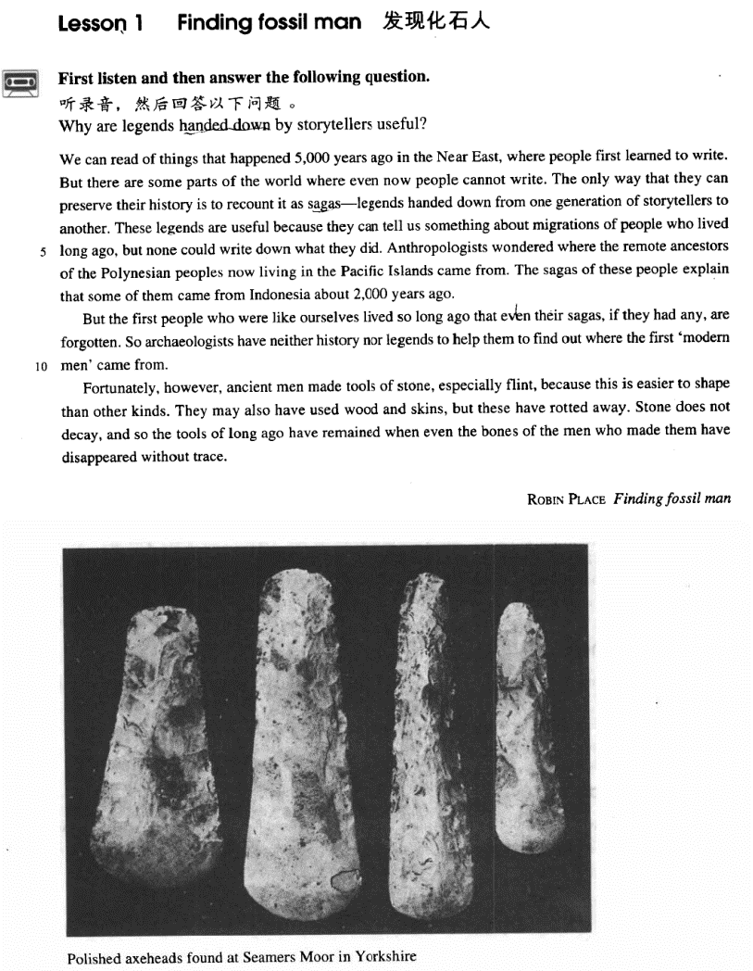

课文
We can read of things that happened 5,000 years ago in the Near East, where people first learned to write.
我们从书籍中可读到5,000 年前近东发生的事情，那里的人最早学会了写字。

But there are some parts of the world where even now people cannot write.
但直到现在,世界上有些地方，人们还不会书写。

The only way that they can preserve their history is to recount it as sagas -- legends handed down from one generation of storytellers to another.
他们保存历史的唯一办法是将历史当作传说讲述，由讲述人一代接一代地将史实描述为传奇故事口传下来。

These legends are useful because they can tell us something about migrations of people who lived long ago, but none could write down what they did.
这些传说是有用的，因为他们告诉我们很久以前生活在这里的移民的一些事情，但是没有人能写下来。

Anthropologists wondered where the remote ancestors of the Polynesian peoples now living in the Pacific Islands came from.
人类学家过去不清楚如今生活在太平洋诸岛上的波利尼西亚人的祖先来自何方，

The sagas of these people explain that some of them came from Indonesia about 2,000 years ago.
当地人的传说却告诉人们：其中一部分是约在2,000年前从印度尼西亚迁来的。

But the first people who were like ourselves lived so long ago that even their sagas, if they had any, are forgotten.
但是，和我们相似的原始人生活的年代太久远了，因此，有关他们的传说既使有如今也失传了。

So archaeologists have neither history nor legends to help them to find out where the first "modern men" came from.
于是，考古学家们既缺乏历史记载，又无口头传说来帮助他们弄清最早的“现代人”是从哪里来的。

Fortunately, however, ancient men made tools of stone, especially flint, because this is easier to shape than other kinds.
然而，幸运的是，远古人用石头制作了工具，特别是用燧石，因为燧石较之其他石头更容易成形。

They may also have used wood and skins, but these have rotted away.
他们也可能用过木头和兽皮，但这类东西早已腐烂殆尽。

Stone does not decay, and so the tools of long ago have remained when even the bones of the men who made them have disappeared without trace.
石头是不会腐烂的。因此，尽管制造这些工具的人的骨头早已荡然无存，但远古时代的石头工具却保存了下来。

词汇讲解

recount
- recount [rɪ'kaʊnt] v. 叙述，讲述

recount / relate / report sth. to sb. 向某人详述某事
tell sb. (about) sth. 【近似词组】表达“向某人详述某事”

- She recounted the events of the previous week to the police.
- We know instinctively, just as beekeepers with their bees, that misfortune might overtake us if the important events of our lives were not related to it.
- History does not relate(讲述) whether his friend accepted his medical help, but in all probability he did.
- After telling several of his friends about the theft, Dimitri found out that his neighbour, Aleko, had suddenly acquired a new lamb.

- 课后题：Lesson03-16
- After ___B___ the theft to several of his friends, …
(A) telling 搭配不对
(B) reporting (report sth. to sb.)
(C) expressing 含义不对
(D) counting 含义不对

【近义词】
narrate vt. 叙述；给…作旁白； vi. 叙述；讲述
narrative n. 叙述；故事；讲述； adj. 叙事的，叙述的；叙事体的

【形近词】
account
account for … 1. 占…的比例；2.解释
- Afro-Americans account for（1.占…的比例） 12% of the US population.
- The gene they discovered doesn’t account for（2.解释） all those cases.

discount n. 折扣；贴现率； v. 打折
- Members get a 20% discount. （打8折）

saga
- saga ['sɑ:gə] n. 长篇英雄传说
saga 英文解释：a prose narrative recorded in Iceland in the Middle Ages. It’s written about the Vikings of Norway and Iceland.

【扩展】
epic n. 史诗；叙事诗；史诗般的作品
legend n.1.传说；传奇故事；2. （尤指某领域中的）传奇人物
- the legend of Robin Hood
- Robin Hood is a legendary hero.

myth / mythology n. 神话；神话学；神话集
- Greek myths / mythology
- He had lived in it as a child when it was already disappearing, and his hero was firmly rooted in his memories and experiences, and in both the history and the mythology of the vanished frontier.

migration
- migration [maɪ'greɪʃn] n. 迁移，移居

【Word Family】【复习】Lesson03-57
migrate v.1.（鸟类、动物等随季节变化）迁徙；2. 移居；迁移
migration n. 迁移；移民；移动
migrant adj. 移居的；流浪的

emigrate v. 移居；移民；移居外国
emigration n. 移民；移民出境；移居外国
emigrant adj. 移民的；移居的
emigrate from 从…移民出去

immigrate v. 移入； 使移居入境
immigration n. 外来移民；移居
immigrant adj. 移民的；迁入的
immigrate to 从…移民进来

- People migrate to cities in search of work.
- Swallows migrate south in winter.
- Europeans emigrating from their homelands after World War Ⅱ were encouraged to immigrate to Australia.
- illegal / permanent immigrants

anthropologist
- anthropologist [7ænθrə'pɒlədʒɪst] n. 人类学家
anthropologist n. 人类学家；人类学者
anthropology n. 人类学

【词根】
“anthrop ” = man

anthropoid n. 类人猿; adj. 类人猿的；类人的；（猿等）似人类的
- Gorillas, chimpanzees and gibbons are all anthropoid apes.

anthropogenic adj. 人为的；[人类] 人类起源的
- The pending extinction of some species are caused by anthropogenic factors, directly or indirectly. 【GRE范文】
- To preserve wilderness areas in their natural state can lessen anthropogenic disturbance to Nature, which is of great importance to the environmental conservation and ecological equilibrium. 【GRE范文】
- I strongly agree with the assertion that significant advances in knowledge require expertise from various fields. The world around us presents a seamless web of physical and anthropogenic forces, which interact in ways that can be understood only in the context of a variety of disciplines. Two examples that aptly illustrate this point involve the fields of cultural anthropology and astronomy. 【GRE范文】

philanthropist n. 慈善家，博爱主义者；乐善好施的人

【词根】
“phil ” = love

philosopher n. 哲学家；哲人

【词根】
“(o)logy ” = to study

biology n. （一个地区全部的）生物；生物学
geology n. 地质学；地质情况
psychology n. 心理学；心理状态
physiology n. 生理学；生理机能
archaeologist n. 生理学；生理机能
archaeology n. 考古学
archaic adj. 古代的；陈旧的

ancestor
- ancestor ['ænsestə(r)] n. 祖先

【词根】
an (=ante) + ces (to go) + tor (person)

- Yandi and Huangdi are the legendary ancestors of the Chinese nation.

【近义词】表达“祖先”：
forefather
forebear

【反义词】表达“后代”：
descendant
- He is a direct descendant of Confucius.

offspring
- the conflict between parents and their offspring

posterity
- These works of art are preserved for posterity.

rot
- rot [rɒt] v. 腐烂
- Too much candy will rot your teeth / make your teeth rot.

rot away 腐烂；烂掉；逐渐腐烂
rotten adj. 腐烂的；堕落的；恶臭的；虚弱的；极坏的
- One rotten apple spoils the whole barrel.

【近义词】表达“腐烂”：
decay n. 衰退，[核] 衰减；腐烂，腐朽
- Too much candy will decay your teeth / make your teeth decay.
- Each civilization is born, it culminates, and it decays（衰退）.

课文讲解

（标题）

Finding fossil man

知识点（1）
标题：Finding fossil man
正确翻译：发现远古人类

知识点（2）
find: discover

知识点（3）
- 课文写法替换：
fossil man: ancient man; prehistoric man

知识点（4）
写作：标题；尽量追去简洁，一般使用音节比较少的词，避免使用大词

- encourage --> spur
- prohibit / forbid --> ban
- compete --> vie
- nominate --> name

知识点（5）
写作：alliteration头韵
- Finding fossil man (Lesson1)
- Spare that spider (Lesson2)
- Matterhorn man (Lesson3)
- The sporting spirit (Lesson6)

- Pride and Prejudice (傲慢与偏见)
- Prince and Pauper (王子与乞丐)
- World Wide Watch (世界观察)
- A Delicious Dish A Day （甜甜饮食）
- Beauty and Beast （美女与野兽）

- Our hopes, our hearts, our hands are with those on every continent who are building democracy and freedom.

- I am in favor of the ingenious, interesting and informative advertisements which give me a lot of enjoyment and inspiration.

- Gre写作范文：
- In sum, the vice president’s conclusion is suspicious. To better evaluate the argument, all of the above-mentioned evidence is definitely needed. A wise decision is always based upon careful scrutiny and concrete, convincing proof, not unclear, unwarranted assumptions and anticipations.（尾韵）

写作：rhyme 尾韵
- Without art, society could still survive, but not thrive.
- Genius is one percent inspiration and ninety-nine percent perspiration.
- Shops cater for the do-it-yourself craze not only by running special advisory services for novices, but by offering consumers bits and pieces which they can assemble at home.

- Gre写作范文：
- Without knowledge, there would be neither basis nor guidance for any progress and development of mankind. Without imagination, human society would lose precious inspiration, innovation and reformation, and eventually grind to a standstill. Thus, while most professions and academic fields necessitate knowledge, imagination is equally important. …

（第一段）

We can read of things that happened 5,000 years ago in the Near East, where people first learned to write.

语法分析：
We can read of things that happened 5,000 years ago（时间状语） in the Near East （地点状语）, where people first learned to write（where… 定语从句，修饰Near East）. （that ...定语从句，修饰things）

知识点（1）
read of 读到
speak of / talk of 谈到
hear of / learn of / know of 听说
think of 想到
dream of 梦到

of … 关于（相当于about）
- Of Truth 关于真理
- Of Death 关于死亡
- Of Love 关于爱情
- Of Envy 关于嫉妒
- Of Human Bondage 关于人性的枷锁

知识点（2）
- 普通语序：事件+地点+时间
- I saw him at the party yesterday.

- 改变正常语序：时间+时间+地点+定语从句；为了句式平衡，避免头重脚轻，改变了正常语序
- We can read of things that happened 5,000 years ago in the Near East, where people first learn to write.

- 改变正常语序：Lesson4
- Several cases have been reported in Russia recently of people who can read and detect colors with their fingers, and even see through solid doors and walls.（of…后置定语，修饰cases）

- 改变正常语序：Lesson5
- He maybe conceited, ill-mannered, presumptuous or fatuous, but I do not turn for protection to dreary clichés about respect of elders — as if mere age were a reason for respect.

- 改变正常语序：Lesson24
- If we glimpse the unutterable, it is unwise to try to utter it, nor should we seek to invest with significance that which we cannot grasp. (invest A with B)

- 考研英语（英译汉）：
- What is an intellectual? I shall define him as an individual who has elected as his primary duty and pleasure in life the activity of thinking in Socratic way about moral problems.

- 考研英语（阅读真题）：
- As a logical consequence of this development, separate journals have now appeared aimed mainly towards either professional or amateur readership（后置定语）.

知识点（3）
the Near East 近东
the Middle East 中东
the Far East 远东

知识点（4）三册复习
- 定语从句充当原因状语
- We can read of things that happened 5,000 years ago in the Near East, where people first learn to write.
- We can read of things that happened 5,000 years ago in the Near East, because people first learned to write there.

- 定语从句充当原因状语Lesson13
- We endeavour to avoid the old, romantic idea of a gusher, which wastes oil and gas.
- We endeavour to avoid the old, romantic idea of a gusher, because it wastes oil and gas.

- 定语从句充当时间状语Lesson03-32
- The small ship, Elkor, which had been searching the Barents Sea for weeks, was on its way home.
- The small ship, Elkor, after she had been searching the Barents Sea for weeks, was on its way home.

- 定语从句充当时间状语Lesson03-22
- Much to the aristocrat's amusement, the gaoler returned a few moments later with a pair of glasses and the usual copy of the letter which he proceeded to read to the prisoner.
- Much to the aristocrat's amusement, the gaoler returned a few moments later with a pair of glasses and the usual copy of the letter and he proceeded to read it to the prisoner.

- 定语从句充当原因状语
- I have to be very careful not to offend the boss, who could fire me at any time.
- I have to be very careful not to offend the boss, because he could fire me at any time.

- 定语从句充当让步状语
- The action, which has aroused universal disapproval, is nevertheless the only solution.
- The action, although it has aroused universal disapproval, is nevertheless the only solution.

知识点（5）【课文仿写】
- 造句：最近几年大批农民工 (migrant workers from the countryside) 涌
入大城市，因为他们在那里可以找到不错的工作并且养活家人。
- The past few years witnessed the great influx of migrant workers from the countryside to big cities, where they could secure decent jobs and support their families.

But there are some parts of the world where even now people cannot write.

知识点（1）
语法：there be 扩展
There seem / appear to be … 好像有
There used to be … 以前有
There happen to be … 碰巧有
There is / are going to be … 即将有

- 造句：有越来越多的人对英语有兴趣。
- There are more and more people who are interested in English.（不地道表达）
- There is growing interest in English.（高级表达：无灵主语 / 物称主语）

- 造句：人们普遍同意妇女应该享有和男人完全的平等。
- People generally agree that women should enjoy full equality with men. （不地道表达）
- There is general agreement that women should enjoy full equality with men. （高级表达：无灵主语 / 物称主语）

知识点（2）
- Lesson04-03
- Except for one or two places such as Zermatt and Chamonix, which had rapidly become popular, Alpine villages tended to be impoverished settlements cut off from civilization.

表达“与文明想隔绝”:
be cut off from …
be out of touch with …
be isolated from …
be separated from …

- These regions are cut off from/out of touch with/ isolated from /separated from civilization.

知识点（3）【课文仿写】
- 造句：但是现在在中国依然有部分地区人们还吃不饱肚子(cannot satisfy one’s hunger)。
- But there are some parts of China where even now people cannot satisfy their hunger.

The only way that they can preserve their history is to recount it as sagas -- legends handed down from one generation of storytellers to another.

语法分析：
The only way that（关系副词） they can preserve their history （that ...定语从句，修饰）is to recount it as sagas—legends handed（过去分词短语做后置定语） down from one generation of storytellers to another（同位语）. （to … 不定式做表语）

知识点（1）
preserve 保存、保护（状态）
- preserve historical records
- preserve food / one’s eyesight

【近义词】【辨析】
conserve 保存、保护（强调数量）
- conserve natural resources
- conserve wildlife

reserve 保存、保护（强调为了将来使用）
- reserve one’s energy
- all rights reserved
- I reserve the right to disagree.
- reserve a table for 2 预定二人桌

- 6级真题： (CET6)
- The old building is in a good state of ___B___ except for the wooden floors.
(A)observation
(B)preservation
(C)conservation
(D)reservation

知识点（2）Lesson03-60
语法：动词不定式做表语时, 若前面出现了实义动词 “do”，则常去掉 “to”
- All I have to do is （to）dream.
- The best thing you can do now is （to）write her an apology.
- All I wanted was to help him.
- The only thing to do was ask them to come half an hour later than the other guests. Then they arrived just when we wanted them.
- The only way that they can preserve their history is to recount it as sagas—legends handed down from one generation of story-tellers to another.
- All I wanted was to help him.

【复习】Lesson03-36
语法：动词不定式做“except / but”的宾语时, 表示“除了…之外”，若前面出现了实义动词 “do”, 则常去掉“to”
1.如果前面实义动词do，后面的to省略
- We have nothing to do but（to） wait here.
- They did nothing but / except（to） complain.
- I’ve done everything you wanted but / except （to）make the beds.

2.如果前面没有实义动词 do，后面必须是to do
- We have no choice but / except to wait here.

知识点（3）
hand sth. down 英文解释：pass sth. from older people to younger ones 传下来
- The recipe was handed down from an ancestor of the family.

知识点（4）
表达“讲…的人”：
story-teller tell stories 讲故事的人
fortune-teller tell one’s fortune 算命

These legends are useful because they can tell us something about migrations of people who lived long ago, but none could write down what they did.

语法分析：
These legends are useful because they can tell us something about migrations of people who lived long ago（because... 原因状语从句）, but none could write down what they did（宾语从句）.

Anthropologists wondered where the remote ancestors of the Polynesian peoples now living in the Pacific Islands came from.

语法分析：
Anthropologists wondered where the remote ancestors of the Polynesian peoples（民族） now living in the Pacific Islands（后置定语） came from. （where… 宾语从句）

知识点（1）
remote ancestors 远祖
a distant relative 远亲
a close / near relative 近亲

知识点（2）
课文写法替换：
- … now living in the Pacific Islands…
- … who live in the Pacific Islands now … （不简洁）

The sagas of these people explain that some of them came from Indonesia about 2,000 years ago.

（第二段）

But the first people who were like ourselves lived so long ago that even their sagas, if they had any, are forgotten.

语法分析：
But the first people who were like ourselves（定语从句） lived so long ago that even their sagas, if（即使，引导让步状语从句） they had any, are forgotten. （that... 引导结果状语）

知识点（1）
- 课文里的替换： 表达“远古人类”：
- the first people who were like ourselves
- fossil man
- people who lived long ago
- the first ‘modern men’
- ancient men

知识点（2）
- 课文写法替换：
- the first people who were like ourselves
- … the first people like ourselves …

be similar to … 和…很类似
- … the first people who were similar to ourselves …
- … the first people similar to ourselves

… resemble 类似
- ... the first people who resembled ourselves …
- ... the first people resembling ourselves …

bear a resemblance to ... 和…很类似
- ... the first people who bore a resemblance to ourselves ...
- ... the first people bearing a resemblance to ourselves ...

- Your school may have done away with winners and losers, but life has not. In some schools they have abolished failing grades; they'll give you as many times as you want to get the right answer. This doesn't bear the slightest resemblance to anything in real life.

知识点（3）
语法：if 从句不一定是条件，也有可能是让步，要根据上下文判断
- God’s reasons, if（即使） He has any, are opaque to us.

- Gre写作范文：
- There is every likelihood that the costs of the monitoring system, such as the purchase, maintenance and updates of software, employment of extra personnel in charge of it, will offset or even outweigh additional revenue, if（即使）there is any.

- His descendants, if any（即使有）, never left the island.
- He is seldom, if ever（即使有，一般不修饰名词，if ever一般用于表时间的副词后，多个seldom搭配）, absent from work.

So archaeologists have neither history nor legends to help them to find out where the first "modern men" came from.

（第三段）

Fortunately, however, ancient men made tools of stone, especially flint, because this is easier to shape than other kinds.

知识点（1）
shape v.使某个东西成形（名词动用）
- He shaped the clay into a vase.
- Like it or not, our experiences shape our personalities.

语法：名词动用
- He thundered at the door.
- The street was veiled in darkness.
- A gust of wind whipped the dust along the road.
- Honey, I forgot to duck. （里根）

知识点（2）三册复习
… this is easier to shape…
语法：形容词后加动词不定式作补语，用主动表被动的含义
- He is easy to fool.
- She is extremely difficult to please.
- The machine is awkward to handle.
- The man is hard to work with.

They may also have used wood and skins, but these have rotted away.

知识点（1）三册复习
语法：对过去肯定/否定的推测
may / might have done
must have done
can not / could not have done
should / ought to have done （责备语气）
should not / ought not to have done

- 练习题：
- -- She looks very happy. She ___C___ have passed the exam.
- -- I guess so. It’s not difficult at all.
(A) should
(B) could
(C) must
(D) might

- 练习题：
- -- I can’t find my purse anywhere.
- --You ___A___ have lost it while shopping.
(A) may
(B) can
(C) should
(D) would

- 练习题：
- -- I’m sorry. I ___B___ at you the other day.
- -- Forget it. I was a bit out of control myself.
(A) shouldn’t shout
(B) shouldn’t have shouted
(C) mustn’t shout
(D) mustn’t have shouted

- 练习题：
- The policeman declared that the blow on the victim’s head ___B___ from behind.
(A) s should have been made
(B) s must have been made
(B) s would have been made
(D) s ought to have been made skin

知识点（2）
表达“皮”：
skin 人皮、兽皮
hide 兽皮
fur 裘皮
feather 羽毛
- fur and feather 飞禽走兽（借代）
- fin, fur and feather 各种各样的动物（借代）

语法现象：metonymy 借代
- A bald（秃头、借代秃头的人） slipped out of the house.
- He has been messing around with several skirts（裙子，借代女性） of his class.
- The crown（皇冠、借代王权） should not yield to the cross（十字架、借代神权）.

Stone does not decay, and so the tools of long ago have remained when even the bones of the men who made them have disappeared without trace.

语法分析：
Stone does not decay, and（并列） so（副词） the tools of long ago have remained when（尽管，引导让步） even the bones of the men who made them have disappeared without trace.

知识点（1）Lesson04-01
语法：when引导让步状语；一般放在主句之后
- He walks when（尽管，引导让步） he might take a taxi.
- Why do you walk when （既然，引导让步）you have a car?
- Stone does not decay, and so the tools of long ago have remained when （尽管，引导让步） even the bones of the men who made them have disappeared without trace.

知识点（2）三册复习
disappear / vanish without trace 消失的无影无踪
- The burglar slipped out of the house and then disappeared / vanished without trace.

（课文总结）
课文总结
写作题材：Problem-Solution Pattern 不断提出问题，不断给出解决方式

